STUDENT RESULT MANAGEMENT SYSTEM

IT23431- MONGODB ESSENTIALS

Submitted by

HARISH DJ – 241001077
JASHWANTH J – 241001092

GEEVAN G. V – 241001061

OF

BACHELOR OF INFORMATION TECHNOLOGY

RAJALAKSHMI ENGINEERING COLLEGE, THANDALAM


(An Autonomous Institution)
RAJALAKSHMI ENGINEERING COLLEGE

BONAFIDE CERTIFICATE

Certified that this project titled “Student Result Management System” is the bonafide work of “ HARISH DJ (241001077),JASHWANTH J(241000192),GEEVAN GV(241001061),” who carried out the project work under my supervision.

SIGNATURE

Dr.Valarmathie HEAD OF THE DEPARTMENT
Information Technology Rajalakshmi Engineering College,
Rajalakshmi Nagar, Thandalam
Chennai – 602105
SIGNATURE

Mrs.Usha S COURSE INCHARGE Information Technology
Rajalakshmi Engineering College, Rajalakshmi Nagar, Thandalam
Chennai - 602105

This project is submitted for IT23431- MONGODB ESSENTIALS
held on ________

INTERNAL EXAMINAR EXTERNAL EXAMINAR
S.NO | TOPIC | PAGE NO
1 | Abstract | 1
2 | Introduction | 1
3 | Purpose | 1
4 | Scope of the project | 2
5 | Software requirement specification | 2
6 | Use case diagram | 3
7 | Entity relationship diagram | 4
8 | Data flow diagram | 5
9 | Module description | 5
10 | Project functionality | 5
11 | Implementation | 11
12 | Conclusion | 11
TABLE OF CONTENTS
STUDENT RESULT MANAGEMENT SYSTEM
1.ABSTRACT
The Student Result Management System is a web-based application developed to manage student academic records efficiently. The system uses MongoDB as the primary database and supports operations such as adding, updating, viewing, and deleting student information. The application is developed using HTML, CSS, and JavaScript for the frontend, and Node.js with Express.js for the backend. MongoDB’s flexible document-oriented model allows storing student data in JSON-like documents, making the system scalable and easy to manage.

2.INTRODUCTION
Managing student results manually is time-consuming and prone to errors. The Student Result Management System is designed to digitize the process of storing and managing student academic records. It provides a centralized platform for administrators to handle student data effectively.

3.PURPOSE
- Develop a system for managing student results digitally
- Reduce manual errors
- Provide quick access to data
- Demonstrate CRUD operations
- Showcase full-stack development

4.SCOPE OF THE PROJECT
- Manage student details
- Record subject-wise marks
- Update and delete records
- Display results

5.SOFTWARE REQUIREMENT SPECIFICATION
Functional Requirements:
- Add, view, update, delete student data
Non-Functional Requirements:
- User-friendly
- Scalable
- Fast
Hardware Requirements:
- 4GB RAM system
Software Requirements:
- HTML, CSS, JavaScript
- Node.js, Express.js
- MongoDB

6.USE CASE DIAGRAM
Admin (1)
│
│
┌─────────────┼────────────────────┐
│ │ │
│ │ │
(Add Student) (Update Student) (DeleteStudent)
│ │ │
│ │ │
(View Student Details) (Manage Marks)
│ │
│ │
(Search Student) (Generate Result / Grade)
│
│
(Login)

7.ENTITY RELATIONSHIP DIAGRAM
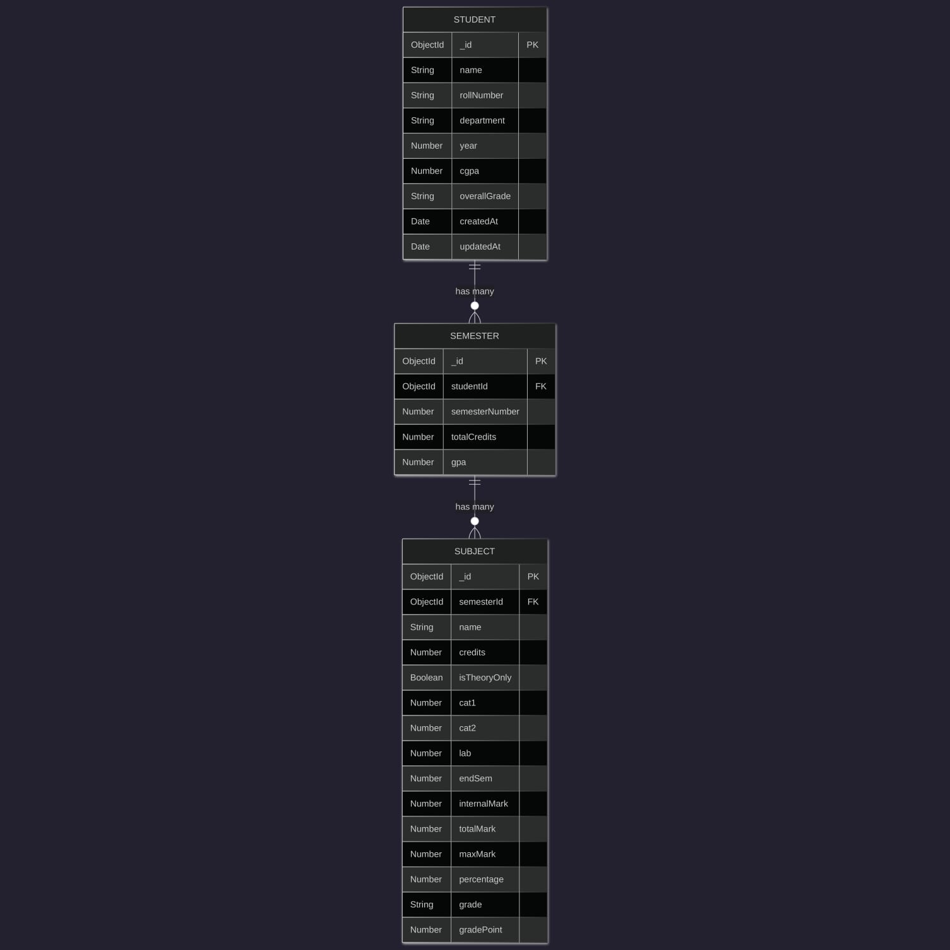

8.DATA FLOW DIAGRAM
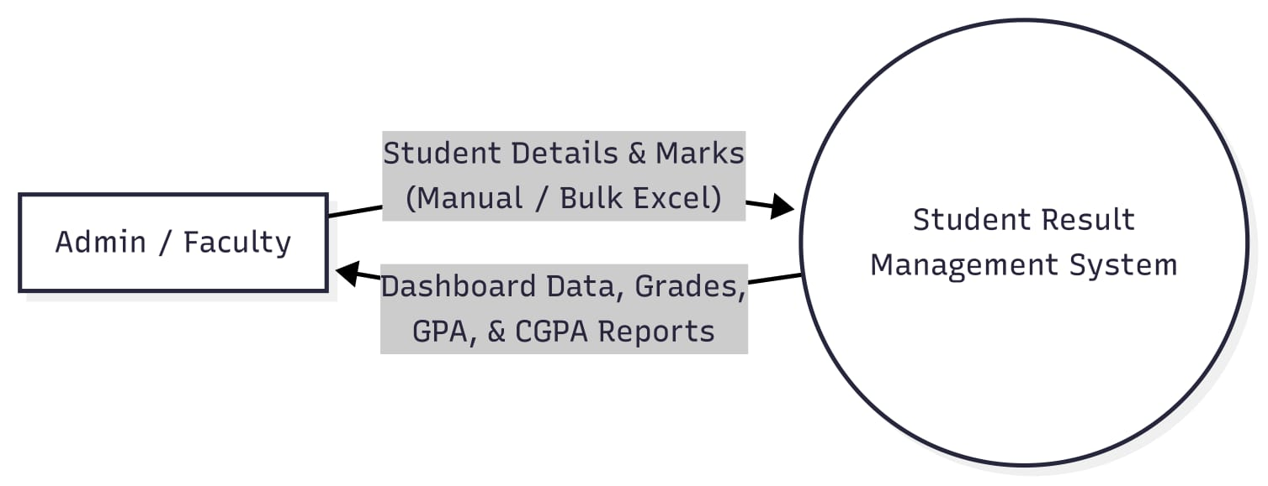

9.MODULE DESCRIPTION
Student Module – manages student data
Marks Module – handles marks
Result Module – displays results
Database Module – stores data

10.PROJECT FUNCTIONALITY
- Student Registration
- Marks Entry
- View Records
- Update/Delete
- Result Generation
BACK END CODE
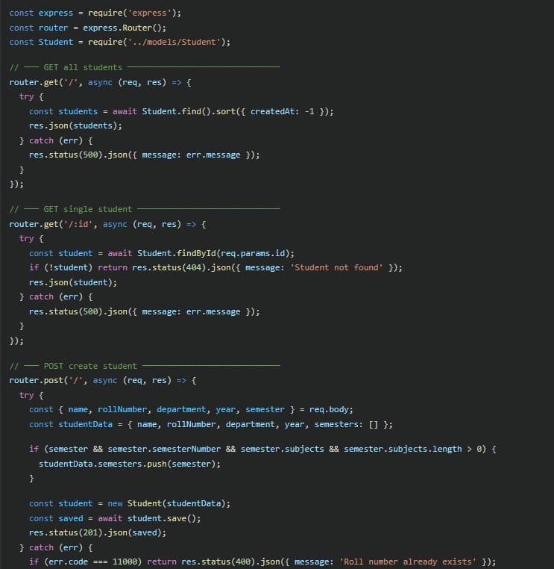
BACK END CODE
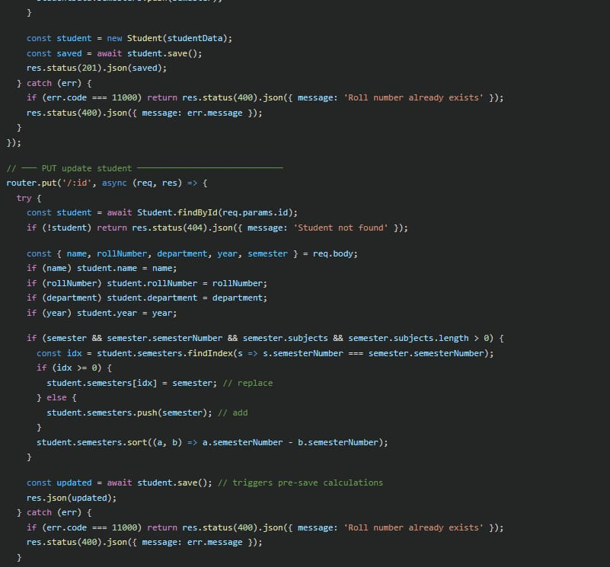

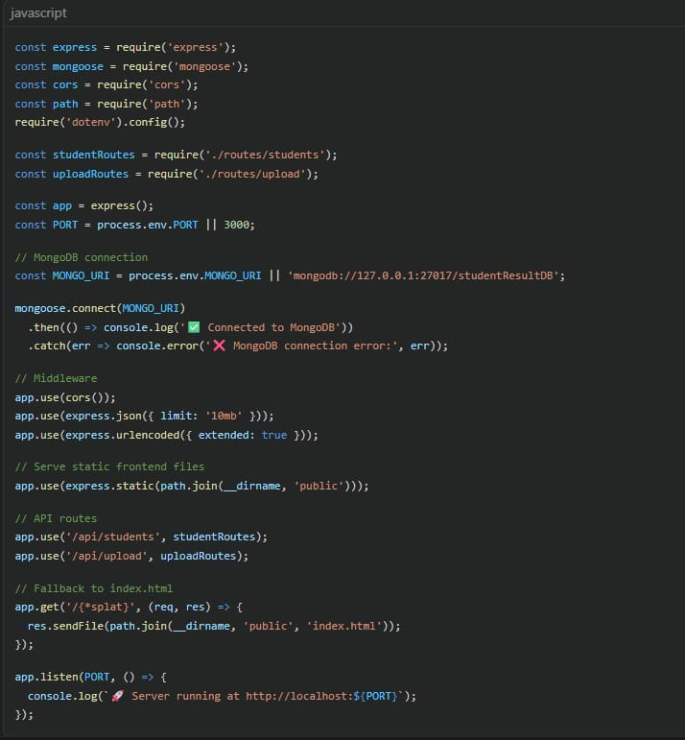
MONGODB CONNECTIVITY CODE

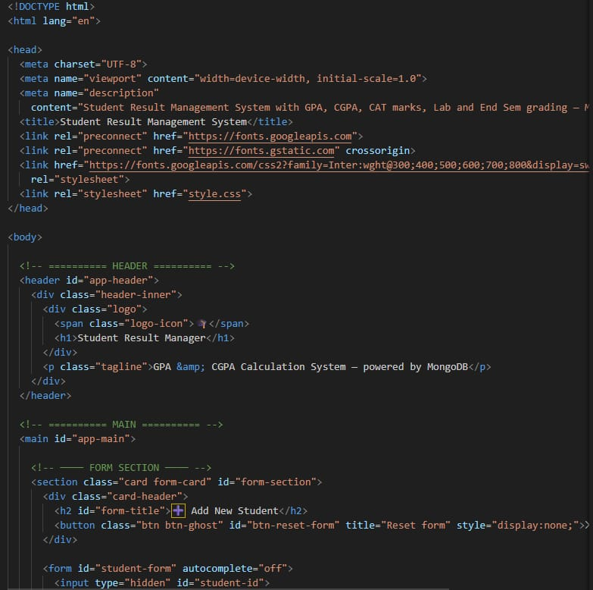
FRONT END CODE

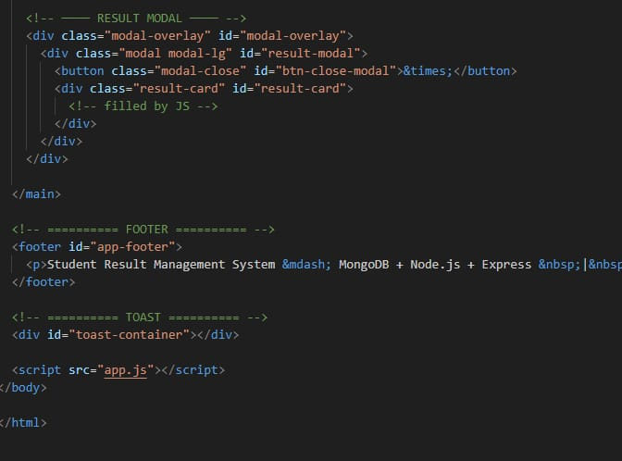
FRONT END CODE

11.IMPLEMENTATION
Three-tier architecture:
Frontend – HTML, CSS, JS
Backend – Node.js, Express
12.CONCLUSION
The system improves efficiency, reduces errors, and demonstrates modern web development with MongoDB.

REFERENCE
MongoDB Docs
Node.js Docs
Express.js Docs
MDN
W3Schools

